**Question NO : 07**

#include<iostream>

using namespace std;

class Node{

public:

int data;

Node* prev;

Node* next;

public:

Node(int d = 0){

data = d;

prev = NULL;

next = NULL;

}

};

class DublyList{

Node* head;

Node* tail;

public:

DublyList(){

head = NULL;

}

void insertAtFirst(int d){

Node* newNode = new Node(d);

if(head == NULL){

head = newNode;

}

else {

newNode->next = head;

head->prev = newNode;

head = newNode;

}

}

void insertAtLast(int d){

Node* newNode = new Node(d);

if(head == NULL){

head = newNode;

}else{

Node* temp = head;

while(temp->next != NULL){

temp=temp->next;

}

newNode->prev = temp;

temp->next = newNode;

}

}

void insertAtCenter(int d){

Node* newNode = new Node(d);

if(head == NULL){

head = newNode;

}

else {

Node* temp = head;

int count = 1;

while (temp->next != NULL)

{

temp = temp->next;

count++;

}

temp = head;

for(int i =1 ; i<=count/2;i++){

temp = temp->next;

}

newNode->next= temp->next ;

newNode->prev =temp;

temp->next->prev = newNode;

temp->next =newNode;

}

}

void insertAtSpecficPosistion(int d ,int pos){

Node* newNode = new Node(d);

if(head == NULL){

head = newNode;

}else if(pos < 1){

cout<<"Invalid Position\n";

}else if(pos == 1){

newNode->next = head;

head->prev = newNode;

head = newNode;

}

else {

Node* temp = head;

for ( int i = 1; i<pos; i++){

temp = temp->next;

if(temp == NULL){

break;

}

}

newNode->prev = temp;

newNode->next = temp->next;

temp->next->prev = newNode;

temp->next = newNode;

}

}

void display_In_Order(){

Node* temp = head;

cout<<"Doubly List : ";

while(temp != NULL){

cout<<temp->data<<" ";

temp = temp->next;

if(temp!= NULL){

cout<< " , ";

}

}

cout<<endl;

}

void displayInreverse(){

Node* temp = head;

cout<<"Revered Doubly List : ";

while(temp->next != NULL){

temp = temp->next;

}

while(temp != NULL){

cout<<temp->data<<" ";

if(temp->prev != NULL){

cout<<" , ";

}

temp = temp->prev;

}

cout<<endl;

}

};

int main(){

DublyList d;

d.insertAtFirst(13);

d.insertAtLast(12);

d.insertAtLast(23);

d.insertAtLast(44);

d.insertAtSpecficPosistion(87,2);

d.display_In_Order();

d.displayInreverse();

d.insertAtCenter(8);

cout<<"-----------------------------------------.\n";

cout<<"After Adding the Center Node.\n";

d.display_In_Order();

d.displayInreverse();

}

**OUTPUT**

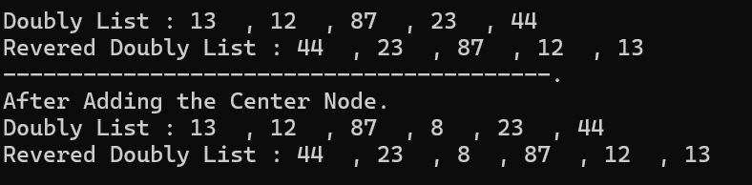

**Explanation**

In this code implements a doubly Linked List with methods to insert nodes at the start, end, center, and specific positions, along with displaying the list in both forward and reverse order. The main function demonstrates inserting nodes and displaying the list before and after adding a center node.